The war in Yemen, which began in 2015, has caused one of the worst food crises of the 21st century. The conflict has disrupted food production, distribution, and markets, leading to widespread food shortages and malnutrition. According to the United Nations, over 24 million people in Yemen are in need of humanitarian assistance, with over 20 million experiencing food insecurity. It is estimated that over 16 million people are in urgent need of food assistance, and the country is facing the world's largest humanitarian crisis.The food crisis in Yemen has been exacerbated by the destruction of infrastructure, including roads, bridges, and ports, which has made it difficult to import food and other essential supplies. The conflict has also led to a collapse in the country's economy, with many people unable to afford food or other basic necessities. The situation has been made worse by the COVID-19 pandemic, which has further strained the country's healthcare system and economy.Overall, the food crisis in Yemen is a tragic example of the devastating impact that war can have on food security and nutrition.

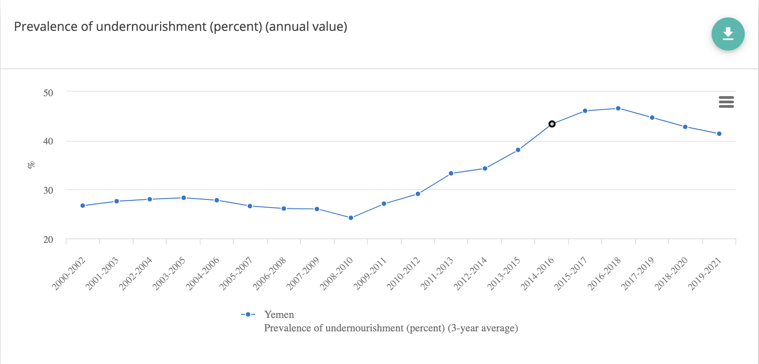

Increase in undernourishment from 2015

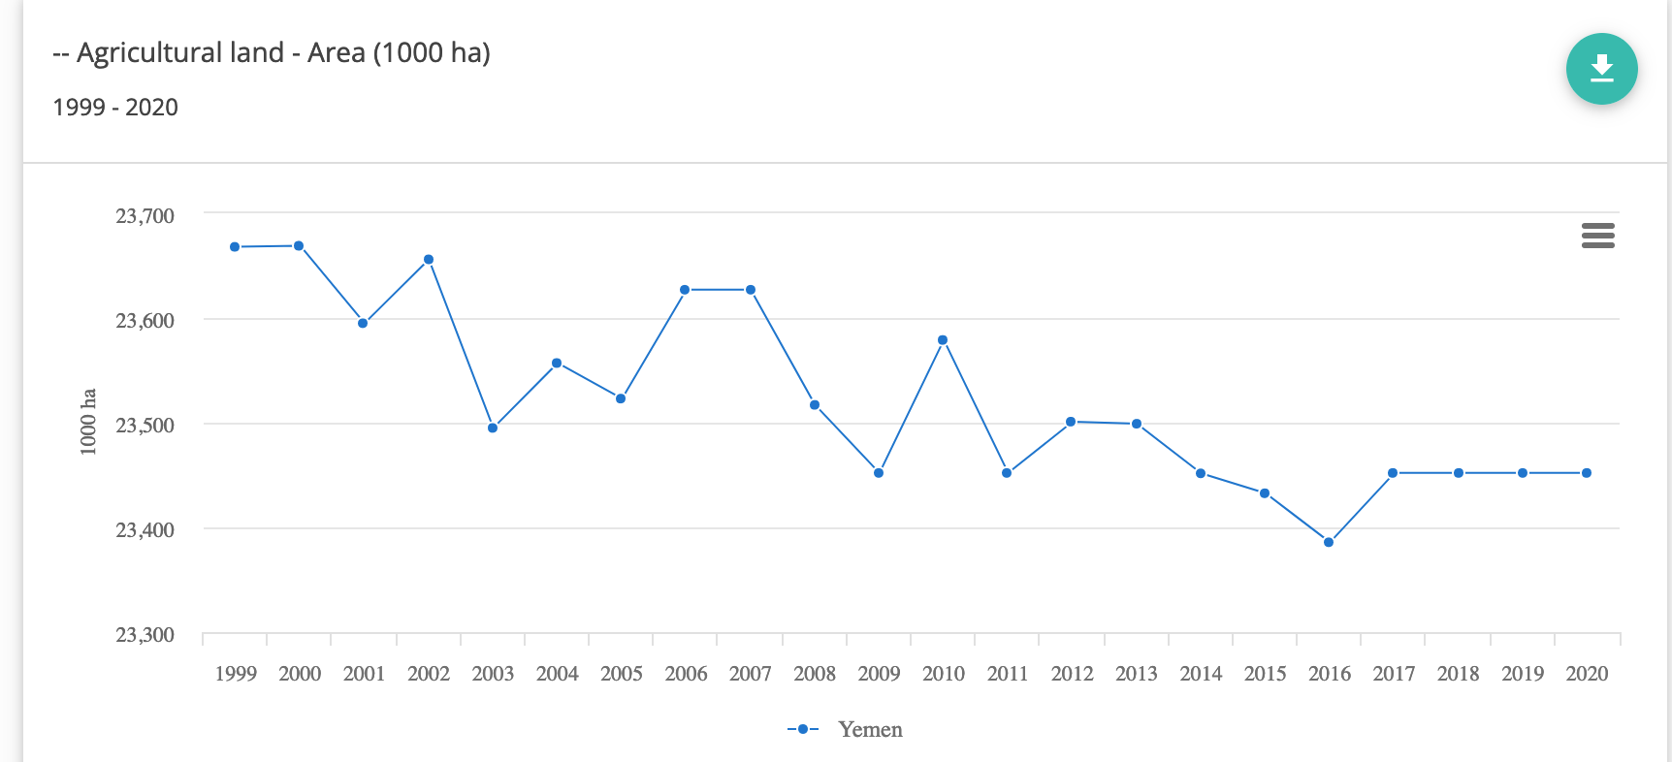

Dip in usage of agriculture land

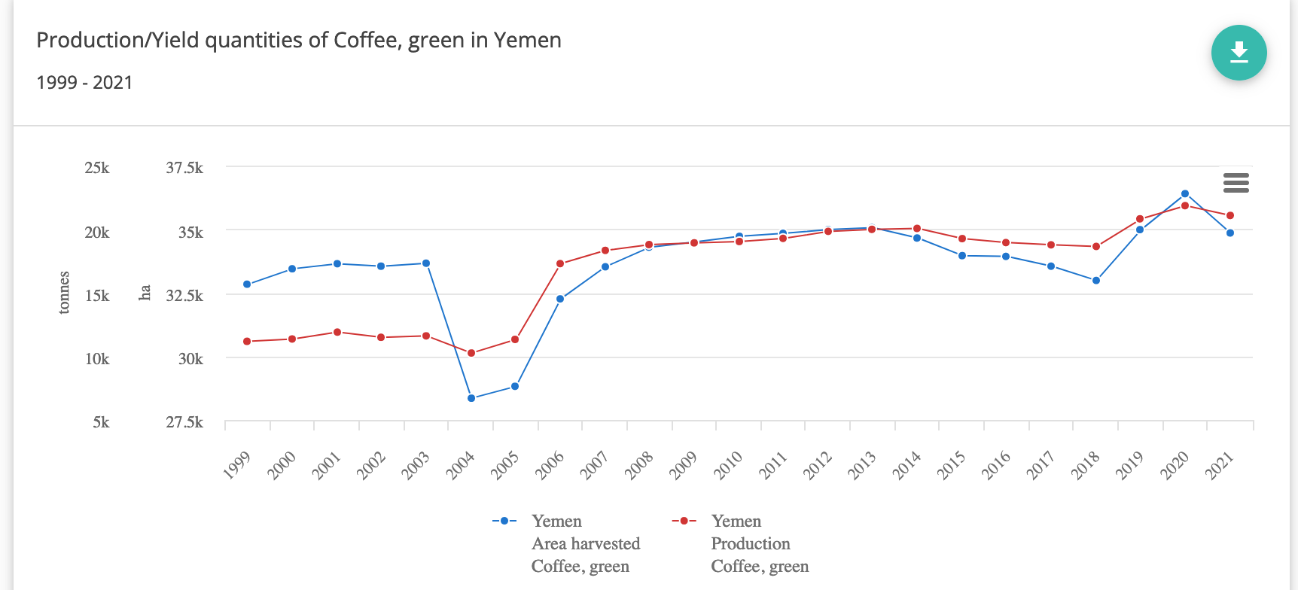

No decrease in coffee production

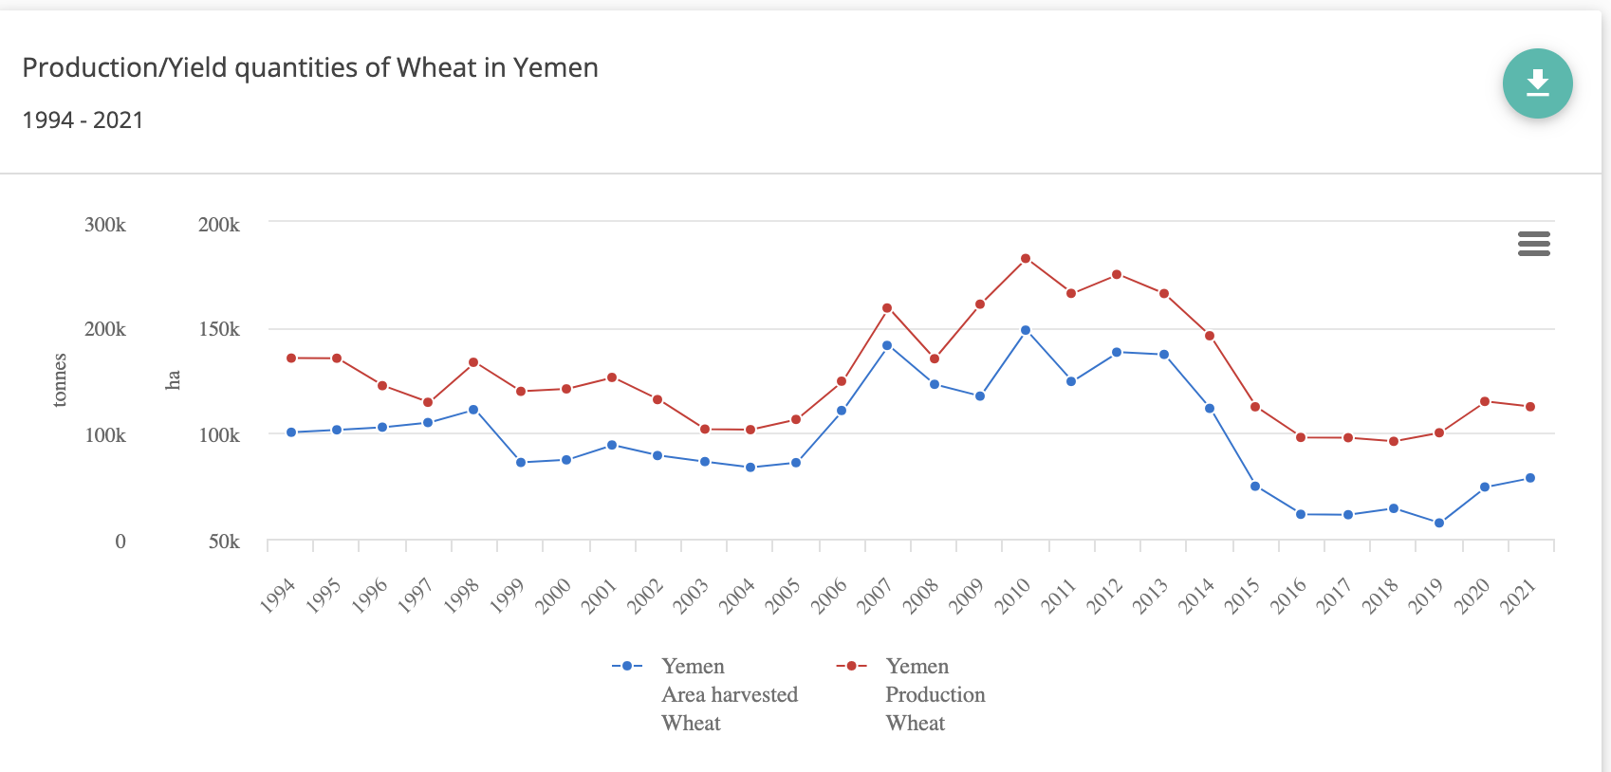

Production of wheat is reduced

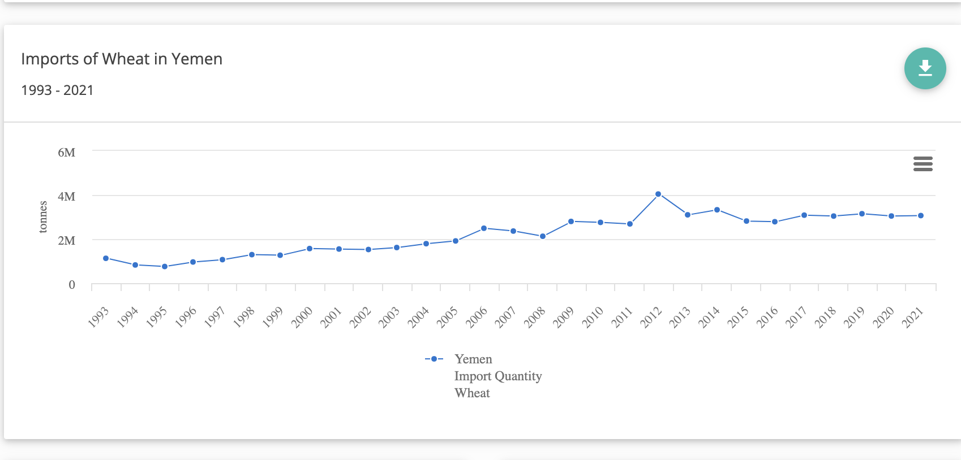

Even though the production of wheat has decreased in Yemen since 2015, imports have not increased. This could be a contributing factor to the increasing food insecurity in the country, although there may be other factors at play.

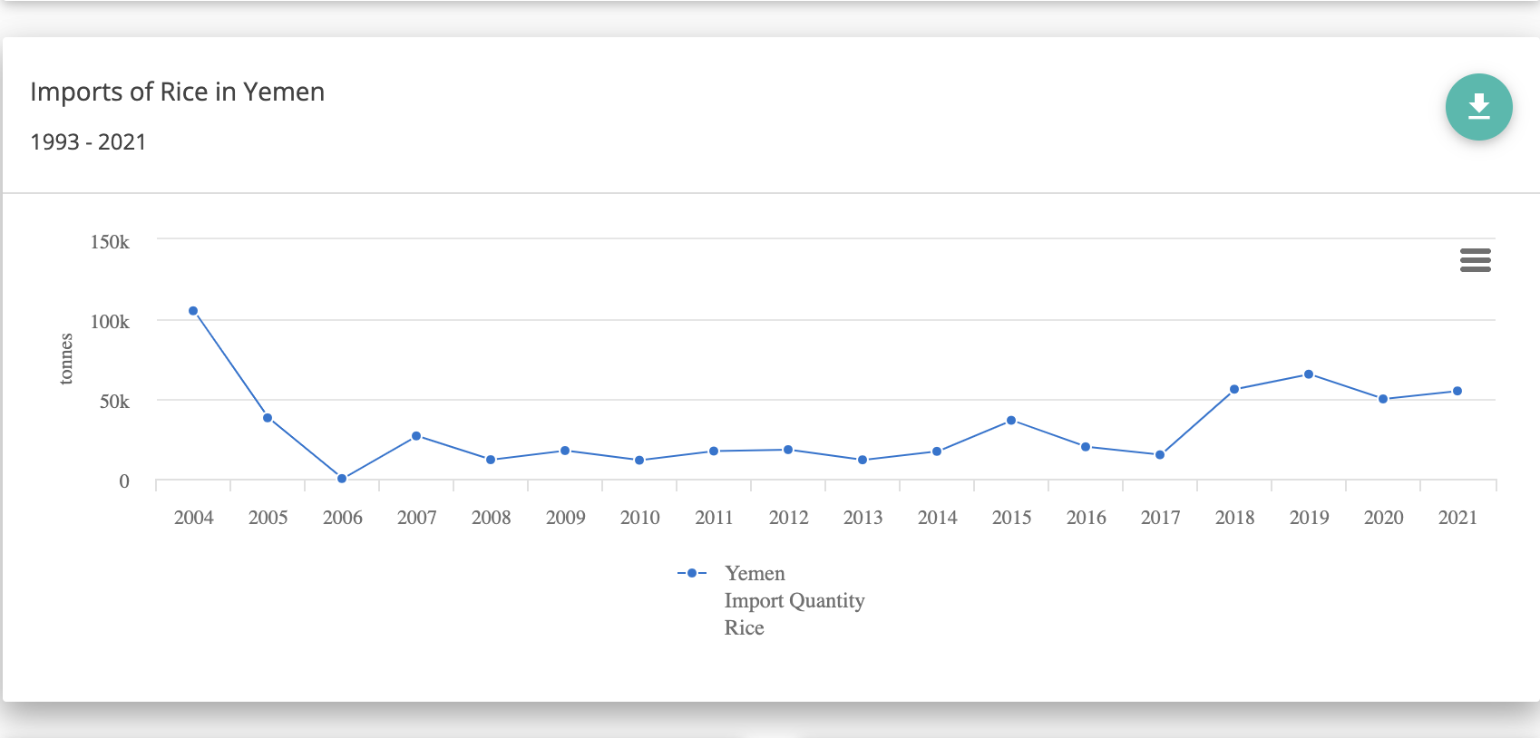

Data is not available for rice production in Yemen

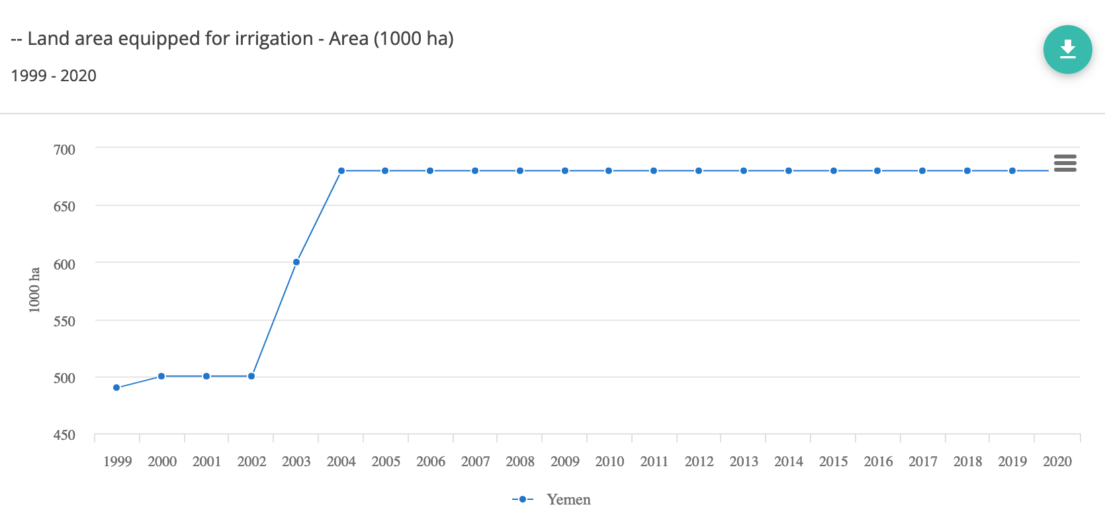

Land area equipped for irrigation is not affected by the war (Most are imputed value)

### Import Overview

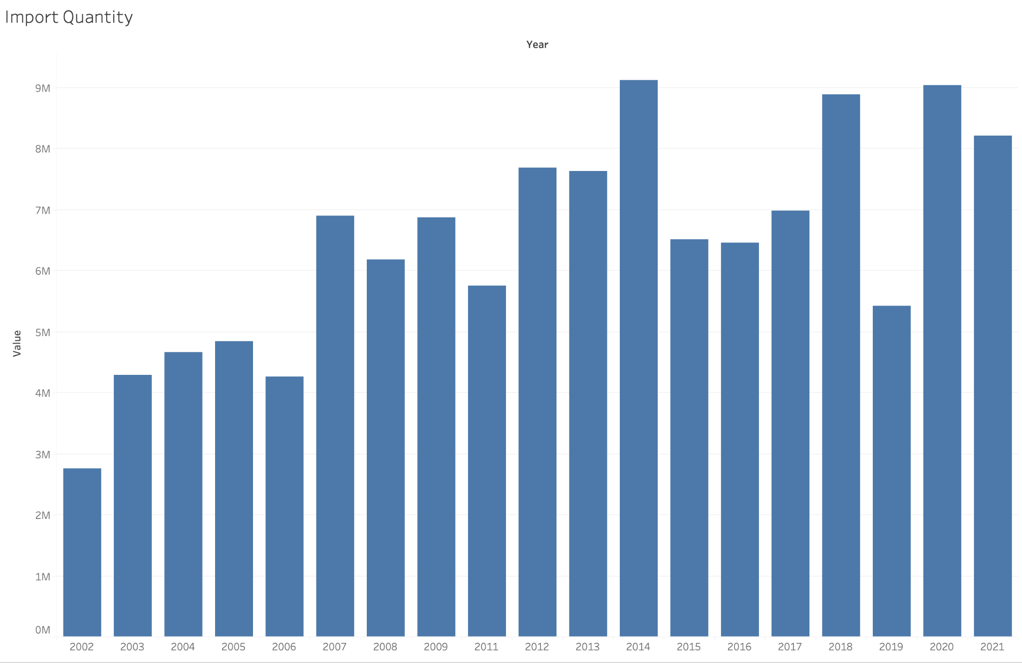

Total Import Quantity has decreased at 2015

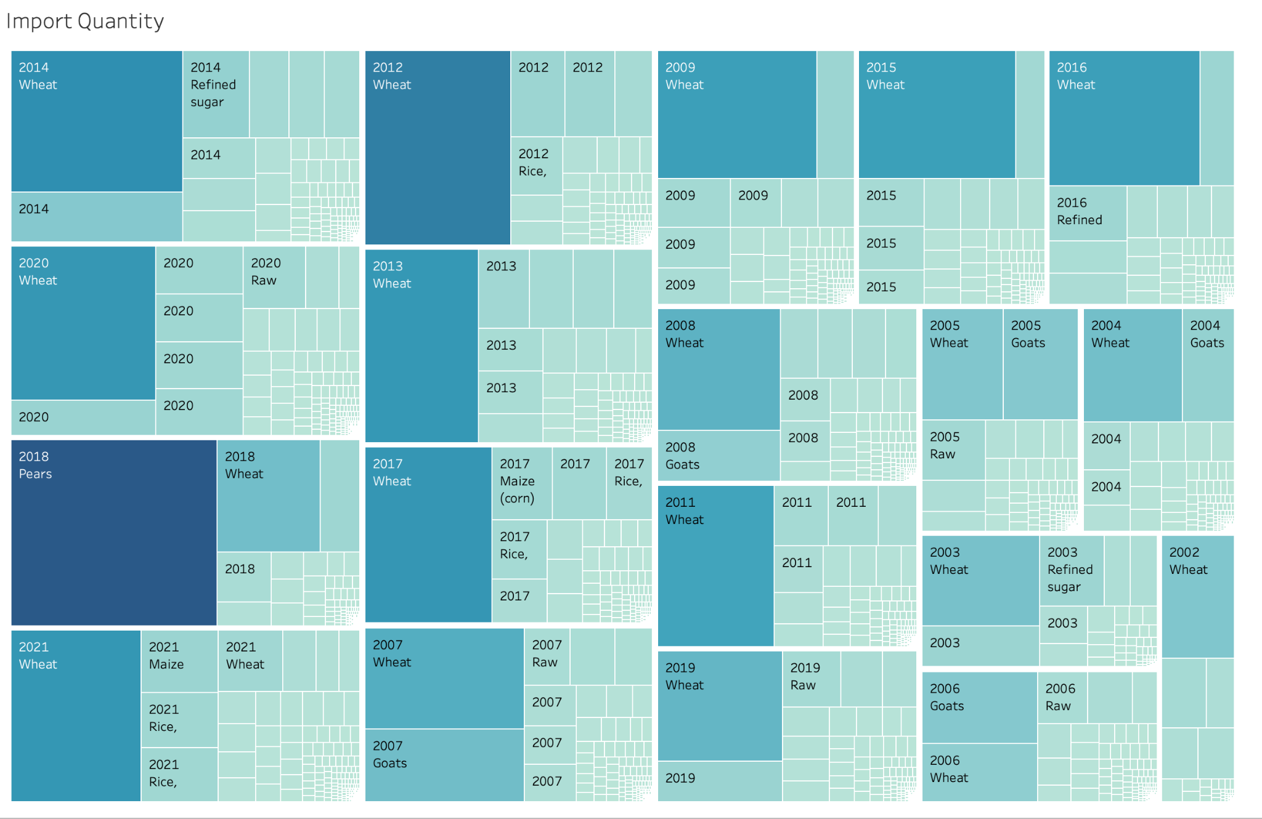

The most imported item every year is wheat (2018 is an exception)

### Export Overview

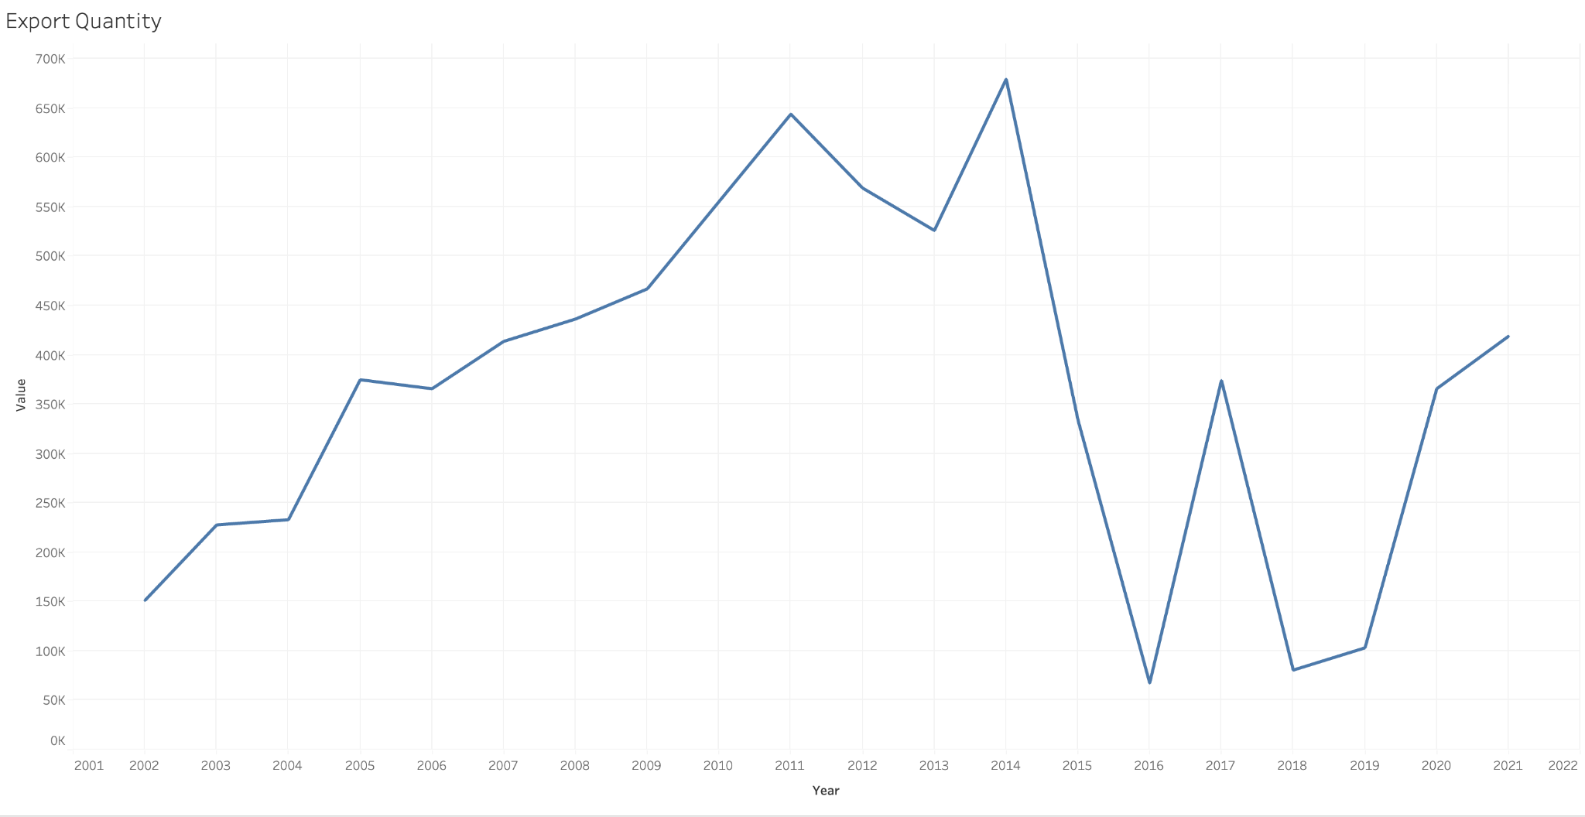

Export has a huge dip in 2015 and 2016 (only focus on data with “tonnes” as unit)

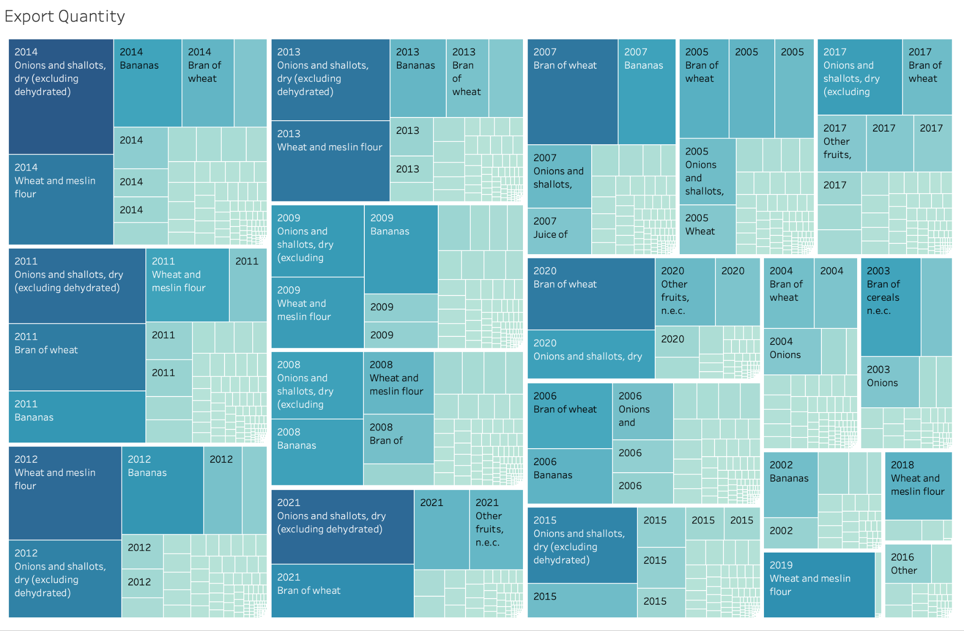

Wheat and Onions are the most exported items (only focus on data with “tonnes” as unit)

### Most produced commodity

Yemen’s most produced commodities are

1. Sorghum

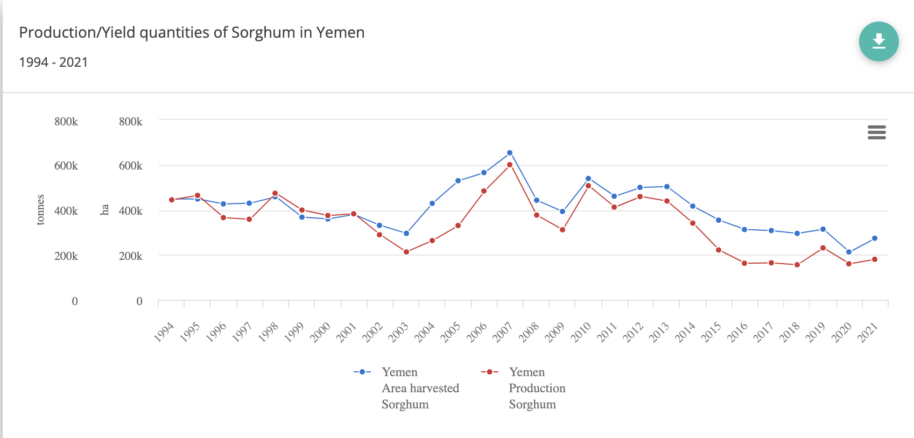

##### Mangoes, guavas and mangosteens

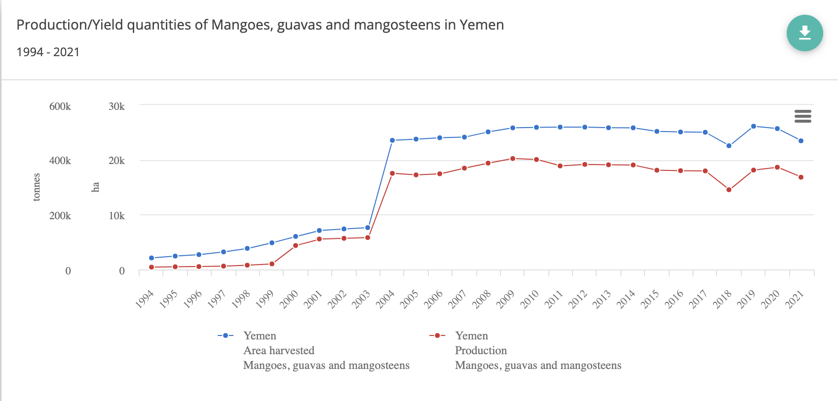

There isn’t a significant change in production

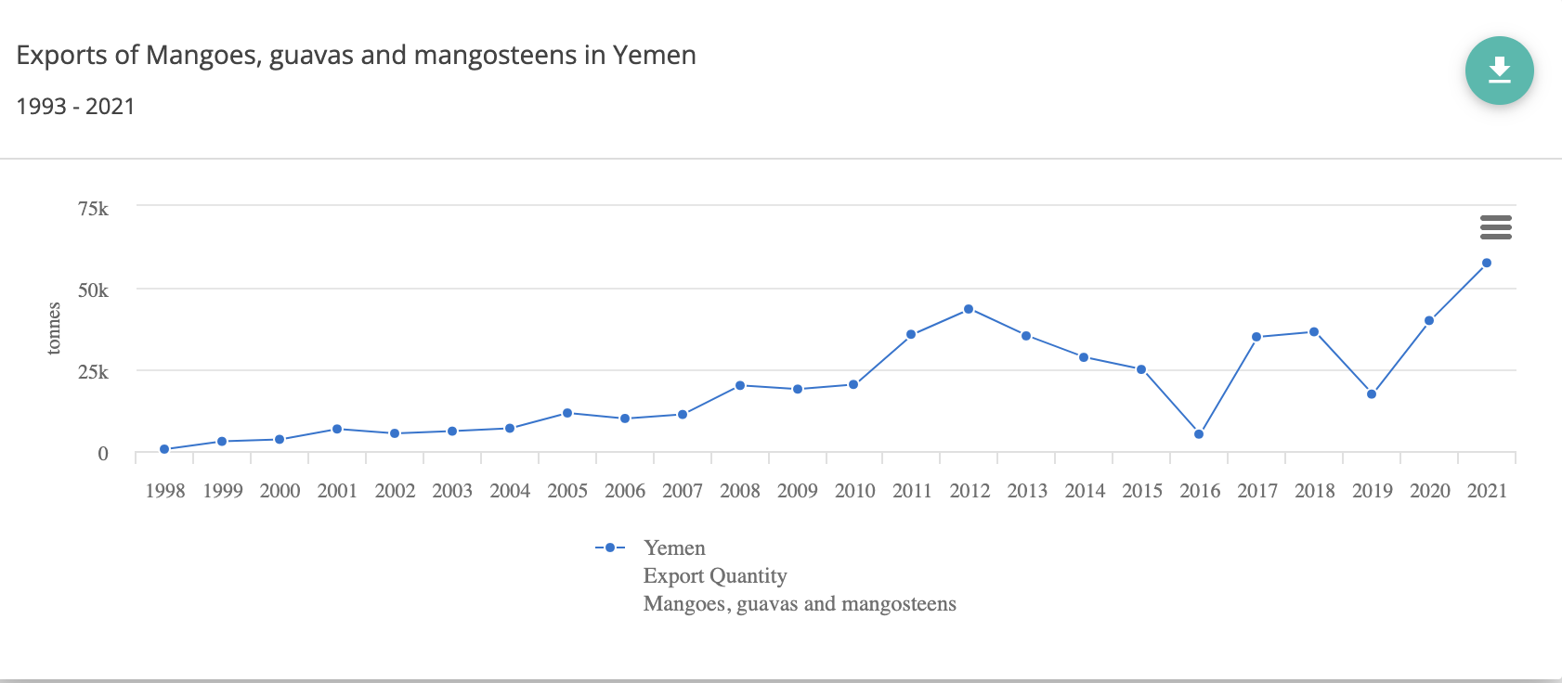

Exports have an overall trend of increase

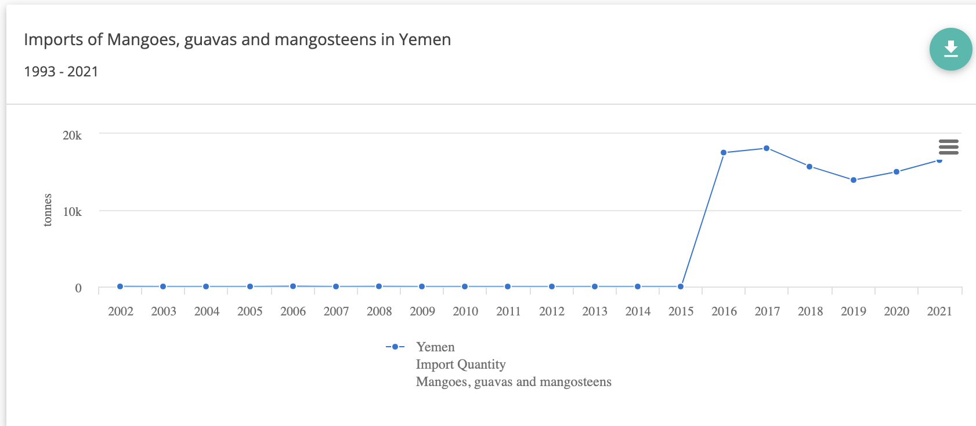

Alse, imports have increased. This doesn’t make sense.

1. Raw milk of cattle

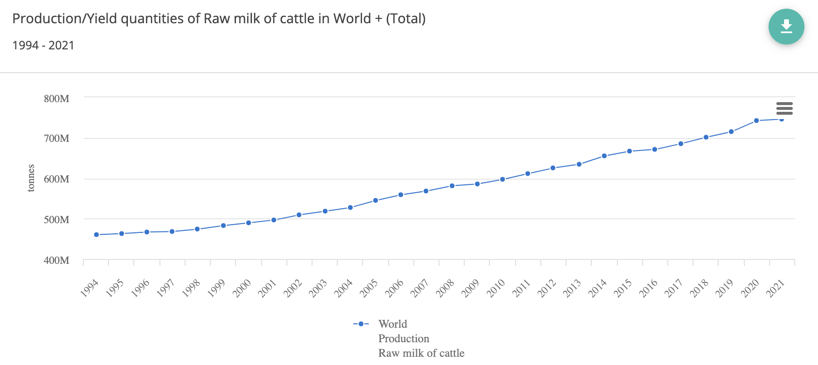Production of raw milk has increased significantly

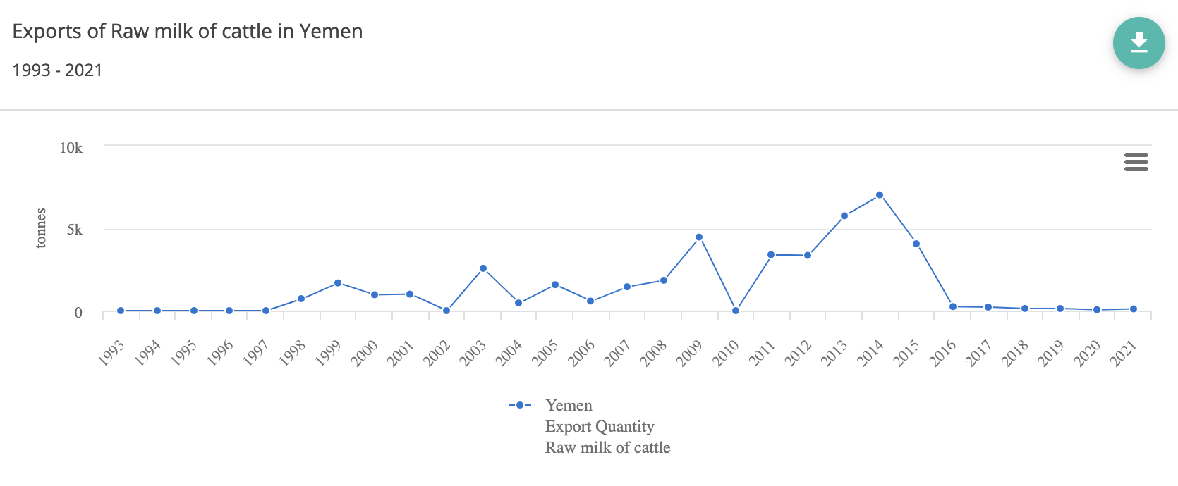

Exports of raw milk decreased significantly

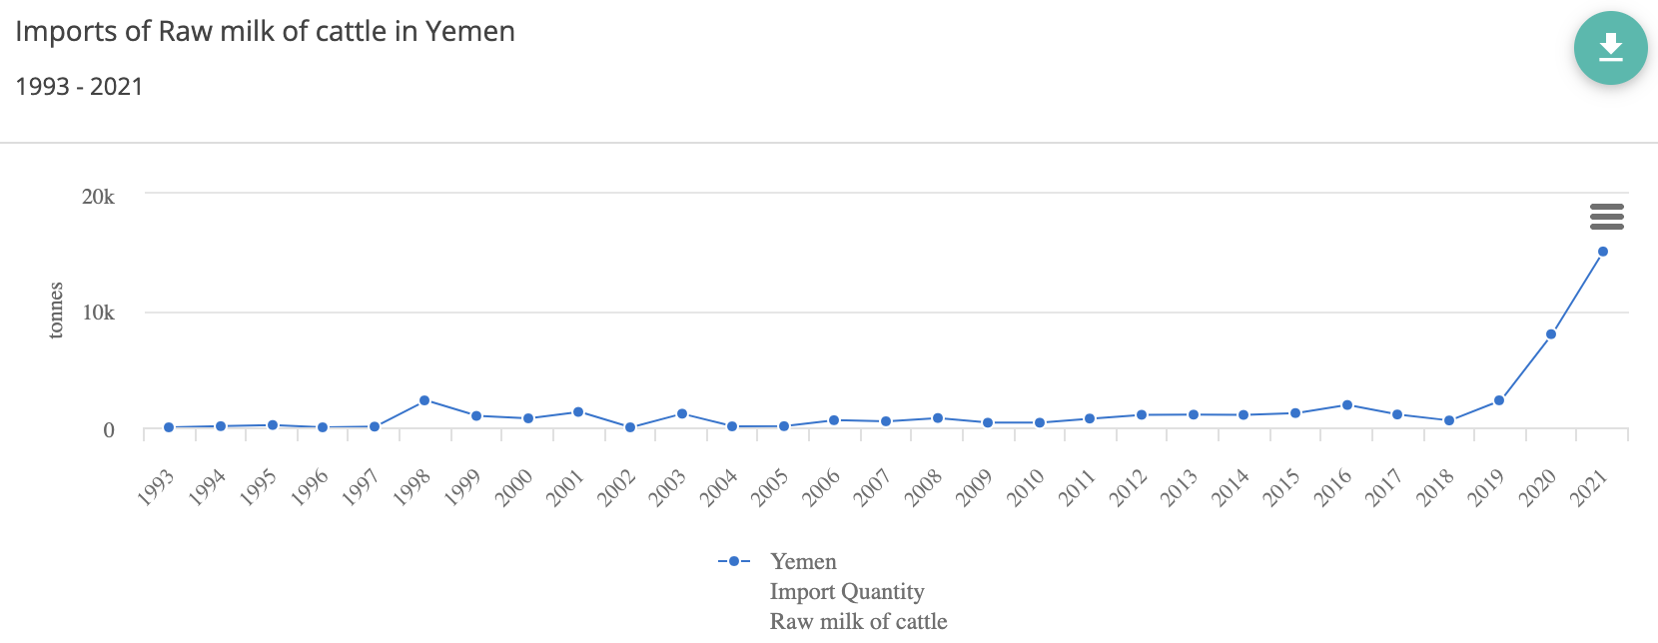

Imports has increased significantly in last 3 years

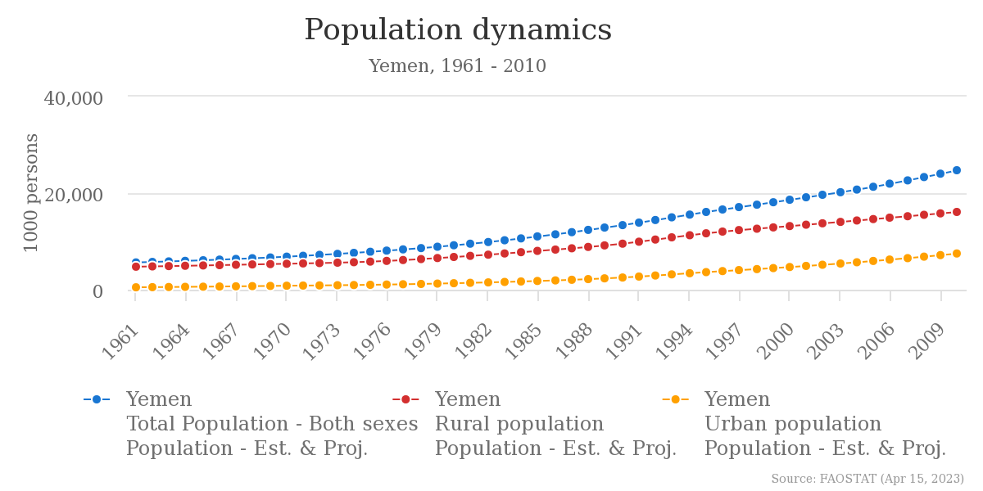

Does imports and production keep up with population growth?

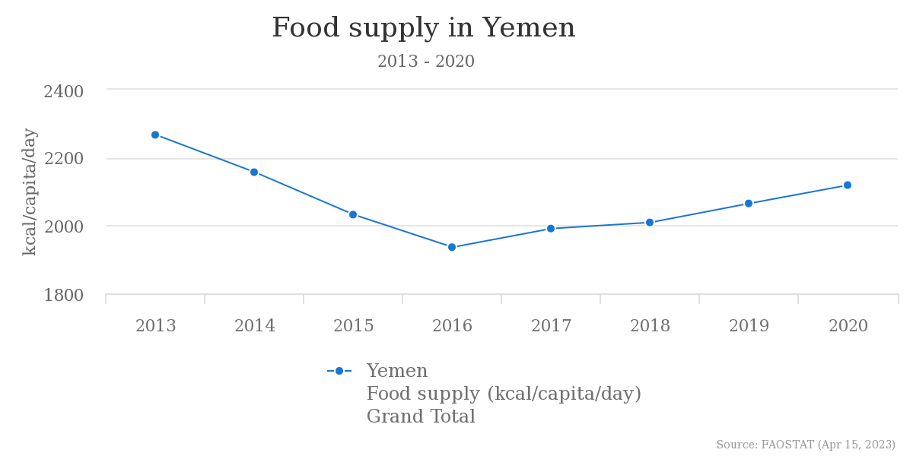

Evaluate changes in countries that imports and exports to/from Yemen.

### Price changes

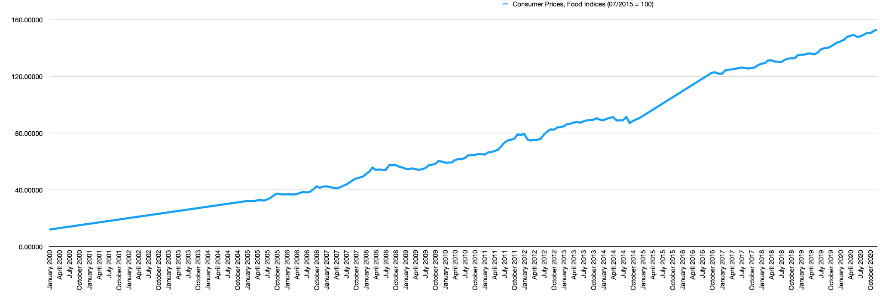

Consumer price, Food Indices has sharp increase after 2015

* (base year is 2015) (2015/7 = 100)

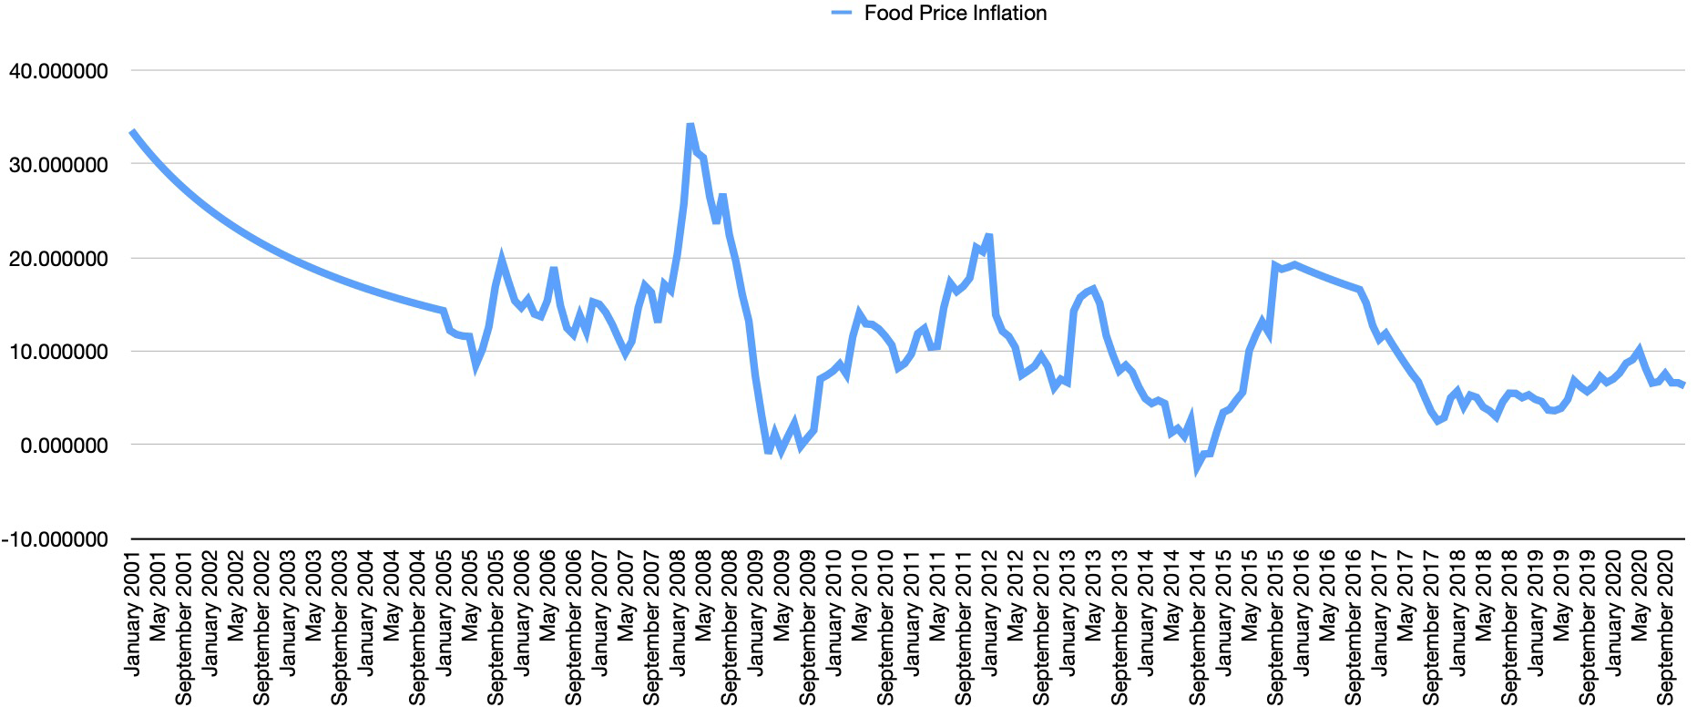

Food Price inflation have several peaks other than 2015

* Peak in 2008 may be due to the this
  + <https://en.wikipedia.org/wiki/2007%E2%80%932008_world_food_price_crisis#Yemen>
  + Food riots in southern Yemen that began in late March and continued through early April, saw police stations torched, and roadblocks were set up by armed protesters. The army has deployed tanks and other military vehicles. Although the riots involved thousands of demonstrators over several days and over 100 arrests, officials claimed no fatalities; residents, however, claimed that at least one of the fourteen wounded people has died

### **Africa undernourishment**

